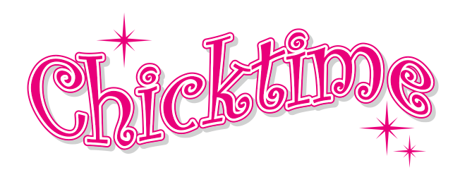
Engaging Monthly Leaders 2026
Click here for instructional video: youtube.com/shorts/4oXwEt-zcHA?feature=shared
***To be facilitated by the Chapter Host to ensure her workshop leaders stay engaged- AND DON’T BAIL OUT ON YOU***
8 weeks prior to their ‘month’ reach out to your workshop leader with a phone call (NOT A TEXT OR EMAIL). Do not ask them if they are still interested, go with their assumed excitement and stay positive. Share how excited you are they are going to lead and ask them if they have any additional details to share. At this point they may want to change their activity which is fine. After the event details are confirmed, answer their questions (how many girls we can expect, etc...) and then direct them to the guidelines for leading a month which you have posted on your ‘How we Serve’ web page. These guidelines include their responsibility of bringing the volunteers they will need to facilitate their activity/workshop as well as the supplies they need. This is critical to help your monthly leaders feel confident... everyone needs a roadmap! *Last thing before ending the call, tell them we are creating a custom invitation for them to post at their work, print out flyers to share with neighbors, email it out., etc. The invitation will help them recruit the volunteers they need to bring to facilitate their activity/workshop.
6 weeks prior to their ‘month’ re-contact the monthly workshop leader (if she hasn’t already contacted you back) and get her workshop confirmations. Make sure she understands it is her responsibility to make sure to bring the volunteers she needs to run her activities. * Check in with your charity partner and ensure the workshops are acceptable. **Share any changes to info@chicktime.com so we can update your calendar at chicktime.com. We use the info on your calendar to create your custom invitations and post them on your website and email to your volunteers. We create dozens of invites every week, please honor our time and do not ask us to change colors or styles. Only typos will be edited.
3 weeks prior to their ‘month’ you will see the upcoming invite posted on your website at Chicktime.com. We recommend that you text a copy of your invite to your monthly workshop leader and thank her for leading! *Your invitation will email out to your database prior to the workshop date. ** FYI... as a gift for YOU to give your charity partner, Chicktime National emails you a revised copy of your custom invitation every month so your charity partner can print and share it with the residents and staff to enjoy. This is also a good time to confirm with your charity partner the number of residents that will be attending the event.
The week before your event is a great time to check in with your workshop leader via text just to tell her how excited you are that she is leading your upcoming workshop!
The week of your event, reach out to your workshop leader and check in, share your gratitude for her! This is kind a nice way to remind her of her commitment. *The National Organization will send the invitation as a reminder to your volunteers. **This is a great time to check in with your charity partner contact to make sure everything is set for Chicktime day
During you event (or within 24 hours afterward), remind Facebook Manager to post a picture from the event and a short write up on your chapter’s Facebook page. The National Organization will post it on your website for you.
These steps are necessary for ongoing retention of volunteers and workshop leaders. If you haven’t been facilitating this type of relationship with your monthly volunteers/workshop leaders, it is likely that your monthly leaders are bailing out just a week or two before their monthly event commitment.
Just remember... strategic contact with workshop leaders is critical prior to their events. BTW... this process is not time consuming... it should take less than 1 hour a month to cover the steps listed here!

